LEWISBURG AREA SCHOOL DISTRICT
LESSON PLAN

Teacher Name: _____Van Wagner______ Class: _________AP Enviro

Topic: ___Env econ and ethics ____ Date of Lesson: __Class #4______

DESIGN QUESTION FOCUS | Introducing New Knowledge | Deepening or Practicing | Generating & Testing Hypotheses

LESSON ESSENTIAL QUESTION: | How do we balance human needs and wants with limited natural resources available?
STANDARD / LEARNING TARGET: | - Describe the resource use by students in highly developed countries  - Contrast this with resource use by people in less developed countries.  Describe the three most important factors that determine human impact on the environment.
ACTIVATING STRATEGIES:  (Anticipatory Set) | Bell Ringer: What is the environmental significance of the process of “consumption”?  a) consumption can outstrip the natural resources available and lead to overexploitation of the environment  b) extravagant consumption can create an environment of raising one’s status among peers  c) the process of consumption is an economic act, providing the “demand” necessary for the “supply” of the environment  d) consumption can generate economic growth that relies significantly on the importation of natural resources, which benefits the environments of less-developed countries  e) consumption is strictly a social act and has no environmental significance  Answer: a  consumption can outstrip the natural resources available and lead to overexploitation of the environment
KEY VOCABULARY: | observation, hypothesis, variable, independent variable, qualitative observation, quantitative observation, data, conclusion, scientific law, scientific theory, constant, inference, prediction,
RESOURCES: | Teacher slide show, demonstration, and lecture.
TEACHING STRATEGIES: | Complete Chapter 1 quiz.  Begin Chapter 2 Environmental Law, Economics, and ethics.  Chapter 2 power point  Students will explore the range of values that economists find to be implicit or regulators state as implicit in various cost-benefit calculations.  Divide students into groups of 3 – 4. First, they will try to come up with a dollar value for human lives. Each group should think about how much value society puts on a human life. Note that not all students will accept that this is a valid way to think about human lives—indeed, not all academics who work on regulatory issues think it’s valid, although most economists do. Some examples they might want to draw on are insurance settlements they may have heard of, or tradeoffs they might be familiar with. Second, they will go on-line to explore the range of values used by regulators or calculated by economists/policy analysts. Finally, they will report their findings back to the class.  Economists often argue that any regulation that saves lives puts an implicit value on human lives. For example, if 100 steel mills are required to spend $10,000 on a scrubber, and those scrubbers are expected to save 2 lives, then the implicit value of one life is 100 times $10,000 divided by 2, or $500,000. Economists also estimate the value of human lives from insurance settlements—for example, how much people win or accept in wrongful death lawsuits.  Working with the assumption that this is a valid way to think about statistical lives (note that you need not believe this—just work with it for now), what value do you think an American life is worth? Are all lives “worth” the same? If not, what would make a life worth more or less? Give examples that you think would stand up in a court of law.  After you have come up with a value or range of values, go to the internet and search for values placed on human lives. Economics and policy literature, and EPA / OSHA / FDA websites might be particularly fruitful resources. What values or ranges did you find? What do you think might account for these differences?  Discuss how students came up with “values”  Take online life insurance calculator. (assume 20 years old)  http://www.lifehappens.org/human-life-value-calculator/  Discuss results. Feel free to change data and resubmit. How did the “value” change.  Discuss.  Read news article and discuss.  Chapter 2 will be FAST> questions due “”at the end of the week (Sunday night AKA whenever I see you in class next week 1st).
EXTENDED THINKING ACTIVITY / ASSIGNMENT: | ***this is a very difficult subject! Can we really ever put a dollar figure on a human life? But do you understand why some number must be assigned for law suits, enviro settlements, etc?  How would we do this for land? What is the “value” of 1 tree? 1 forest? 1 deer? A deer herd.
SUMMARIZATION/ CLOSURE: | Exit Bell Ringer: There are 6 components of an Environmental Impact Statement. Write down at least 1.  Answer:  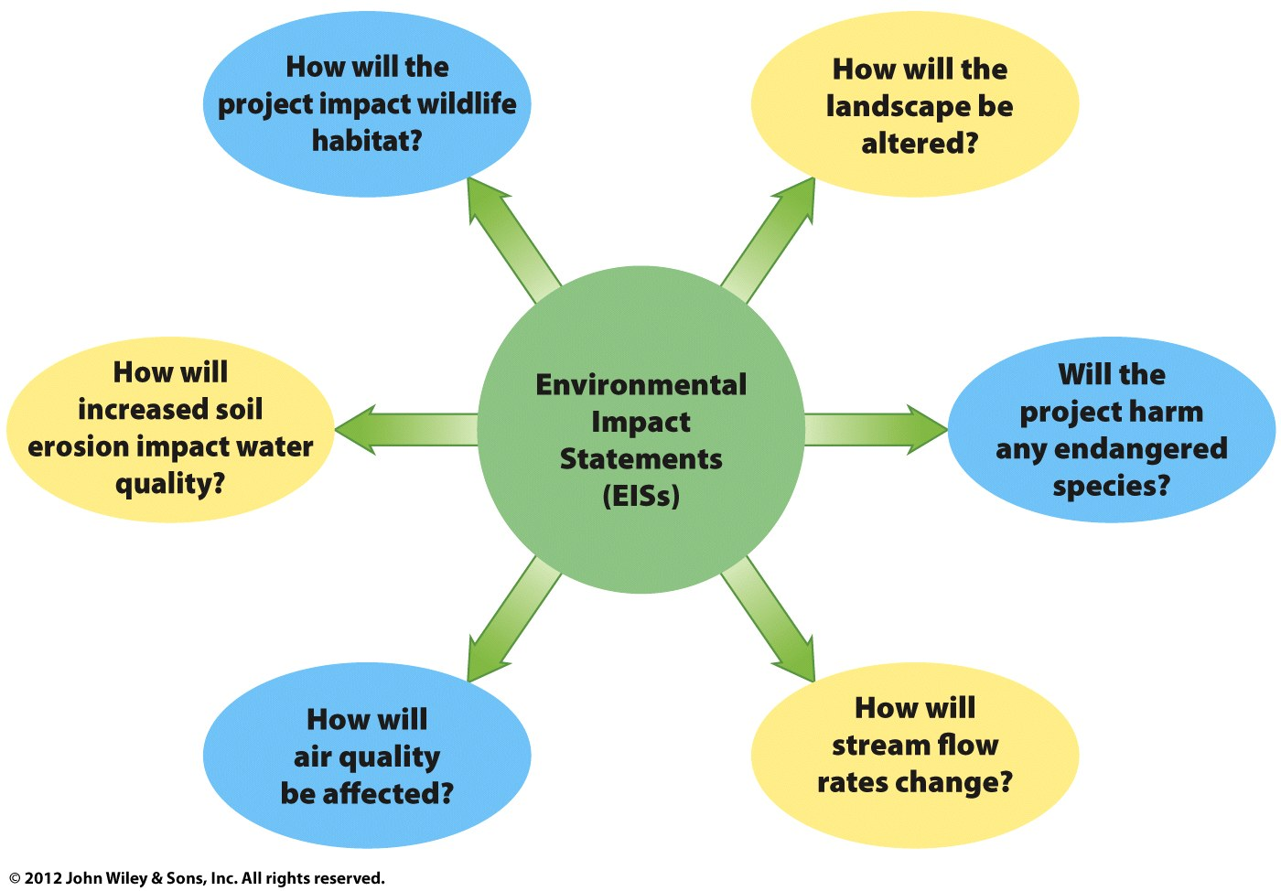
ADAPTATIONS for  HISTORICALLY UNDERPERFORMING STUDENTS |  | Instructions will be given orally as well as in written form.  I will continue to develop close personal relationships with my students to better identify ways to reach each learner.
FORMATIVE ASSESSMENT |  | Chapter 1 quiz will be scored and reviewed shortly.

